## Data Sources:

[https://www.uscis.gov/tools/reports-studies/h-1b-employer-data-hub-files](https://nam03.safelinks.protection.outlook.com/?url=https%3A%2F%2Fwww.uscis.gov%2Ftools%2Freports-studies%2Fh-1b-employer-data-hub-files&data=02%7C01%7CNVipperla%40walton.uark.edu%7C0a791feb9aac4d5468bf08d7da66b263%7C79c742c4e61c4fa5be89a3cb566a80d1%7C0%7C0%7C637218006915542478&sdata=MuW1yUlktd5r4WD7Kis2ad2%2BzyvxPW%2B9r9OlLS8rpxw%3D&reserved=0)

[https://www.iie.org/Research-and-Insights/Open-Doors](https://nam03.safelinks.protection.outlook.com/?url=https%3A%2F%2Fwww.iie.org%2FResearch-and-Insights%2FOpen-Doors&data=02%7C01%7CNVipperla%40walton.uark.edu%7C0a791feb9aac4d5468bf08d7da66b263%7C79c742c4e61c4fa5be89a3cb566a80d1%7C0%7C0%7C637218006915552479&sdata=Q0oVM07P4Lj9I3ng732B5rEhCURmSHPgCeHMfGQ5zVU%3D&reserved=0)

[https://travel.state.gov/content/travel/en/legal/visa-law0/visa-statistics/nonimmigrant-visa-statistics.html](https://nam03.safelinks.protection.outlook.com/?url=https%3A%2F%2Ftravel.state.gov%2Fcontent%2Ftravel%2Fen%2Flegal%2Fvisa-law0%2Fvisa-statistics%2Fnonimmigrant-visa-statistics.html&data=02%7C01%7CNVipperla%40walton.uark.edu%7C0a791feb9aac4d5468bf08d7da66b263%7C79c742c4e61c4fa5be89a3cb566a80d1%7C0%7C0%7C637218006915542478&sdata=xoTYTce4MoZ0S8IanR%2BvKTONersckLJrWvkJ%2BOc1y3M%3D&reserved=0)

[https://collegescorecard.ed.gov/data/](https://nam03.safelinks.protection.outlook.com/?url=https%3A%2F%2Fcollegescorecard.ed.gov%2Fdata%2F&data=02%7C01%7CNVipperla%40walton.uark.edu%7C0a791feb9aac4d5468bf08d7da66b263%7C79c742c4e61c4fa5be89a3cb566a80d1%7C0%7C0%7C637218006915532482&sdata=T3ban2b9H54CiRwJKqJEeJb2xNjGJu%2B%2BJbjYMGVpNyE%3D&reserved=0) -- API source

https://www.foreignlaborcert.doleta.gov/performancedata.cfm

## Dimensional Design:

### Initial Model:

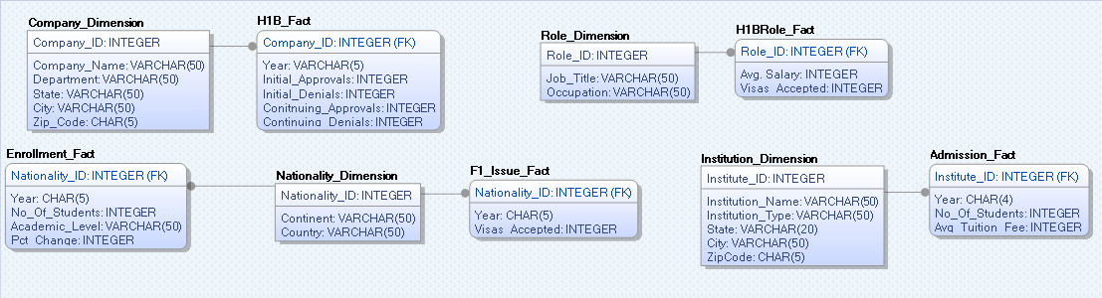

### Final Model:

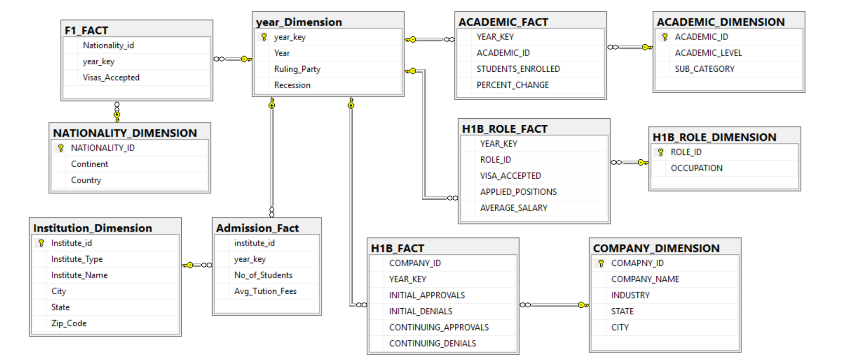

## Data Dictionary:

### Dimension Tables:

ACADEMIC_DIMENSION

|  |  |  |  |
| --- | --- | --- | --- |
| Column name | Key specifications | Datatype | Description |
| ACADEMIC_ID | PRIMARY KEY | INTEGER  NOT NULL | Unique identifier representing an academic record |
| ACADEMIC_LEVEL |  | VARCHAR (20), NOT NULL | Academic level at the University |
| SUB_CATEGORY |  | VARCHAR (30), NOT NULL | Sub category in academic level |

INSTITUTION_DIMENSION

|  |  |  |  |
| --- | --- | --- | --- |
| Column name | Key specifications | Datatype | Description |
| INSTITUTION_ID | PRIMARY KEY | INTEGER,  NOT NULL | Unique identifier representing an institution record |
| INSTITUTION_TYPE |  | VARCHAR (100), NULL | Type of institution |
| INSTITUTION _NAME |  | VARCHAR (500), NULL | Name of the institution |
| CITY |  | VARCHAR (150), NULL | Name of the City in which the institution operates |
| STATE |  | VARCHAR (2), NULL | Code of the State in which the institution operates |
| ZIP_CODE |  | CHAR (20), NULL | Zip code of the area in which the institution operates |

H1B_ROLE_DIMENSION

|  |  |  |  |
| --- | --- | --- | --- |
| Column name | Key specifications | Datatype | Long description |
| ROLE_ID | PK | INTEGER, NOT NULL | Unique identifier for each role. |
| OCCUPATION |  | VARCHAR (200), NOT NULL | Occupation |

YEAR_DIMENSION

|  |  |  |  |
| --- | --- | --- | --- |
| Column name | Key specifications | Datatype | Long description |
| YEAR_KEY | PRIMARY KEY | INTEGER, NOT NULL | Unique numerical identifier of each year |
| YEAR |  | CHAR (4), NULL | Calendar Year |
| RULING_PARTY |  | VARCHAR (15), NULL | Ruling party for the year |
| RECESSION |  | VARCHAR (5), NULL | Describes whether the year was a recession year or not |

NATIONALITY_DIMENSION

|  |  |  |  |
| --- | --- | --- | --- |
| Column name | Key specifications | Datatype | Long description |
| NATIONALITY_ID | PK | INTEGER, NOT NULL | Unique numerical identifier of each nationality |
| CONTINENT |  | VARCHAR (50), NULL | Name of the continent |
| COUNTRY |  | VARCHAR (50), NULL | Name of the country |

COMPANY_DIMENSION

|  |  |  |  |
| --- | --- | --- | --- |
| Column name | Key specifications | Datatype | Description |
| COMPANY_ID | PK | INTEGER,  NOT NULL | Unique identifier representing the company |
| COMPANY_NAME |  | VARCHAR (100), NOT NULL | Name of the company |
| INDUSTRY |  | VARCHAR (50), NOT NULL | The division to which a location is assigned for operational purposes. |
| CITY |  | CHAR (2), NULL | The city where the store is located. |
| STATE |  | VARCHAR (50), NULL | The state abbreviation where the company is located. |

### Fact Tables:

ACADEMIC_FACT

|  |  |  |  |
| --- | --- | --- | --- |
| Column name | Key specifications | Datatype | Long description |
| YEAR_KEY | FOREIGN KEY | INTEGER, NOT NULL | Unique identifier representing a year |
| ACADEMIC_ID | FOREIGN KEY | INTEGER, NOT NULL | Unique identifier representing an academic record |
| STUDENTS_ENROLLED |  | INTEGER, NOT NULL | Number of students enrolled |
| PERCENT_CHANGE |  | INTEGER, NOT NULL | Percentage change in student enrollment |

ADMISSION_FACT

|  |  |  |  |
| --- | --- | --- | --- |
| Column name | Key specifications | Datatype | Long description |
| INSTITUTE_ID | FOREIGN KEY | INTEGER, NOT NULL | Unique identifier representing an admission record |
| YEAR_KEY | FOREIGN KEY | INTEGER, NOT NULL | Year of admission |
| NO_OF_STUDENTS |  | INTEGER, NULL | Number of students at the university |
| AVG_TUTION_FEES |  | INTEGER, NULL | Average Tuition Fee |

H1B_FACT

|  |  |  |  |
| --- | --- | --- | --- |
| Column name | Key specifications | Datatype | Long description |
| COMPANY_ID | FOREIGN KEY | INTEGER, NOT NULL | Unique identifier representing the company |
| YEAR_KEY | FOREIGN KEY | INTEGER, NOT NULL | Unique identifier representing the year |
| INITIAL_APPROVAL |  | INTEGER, NULL | H1B petitions approval for first time applicants |
| INITIAL_DENIAL |  | INTEGER, NULL | H1B petitions denials for first time applicants |
| CONTINUING_APPROVAL |  | INTEGER, NULL | H1B petitions approval for renewals |
| CONTINUING_APPROVAL |  | INTEGER, NULL | H1B petitions denials for renewals |

H1B_ROLE_FACT

|  |  |  |  |
| --- | --- | --- | --- |
| Column name | Key specifications | Datatype | Long description |
| YEAR_KEY | FOREIGN KEY | INTEGER, NOT NULL | Unique identifier for each year. |
| ROLE_ID | FOREIGN KEY | INTEGER, NOT NULL | Unique identifier for each role. |
| VISA_ACCEPTED |  | INTEGER, NULL | Number of visas accepted |
| APPLIED_POSITION |  | INTEGER, NULL | Number of applications for the position |
| AVERAGE_SALARY |  | INTEGER, NULL | Average salary for the position |

F1_FACT

|  |  |  |  |
| --- | --- | --- | --- |
| Column name | Key specifications | Datatype | Long description |
| NATIONALITY_ID | FOREIGN KEY | INTEGER, NOT NULL | Unique numerical identifier of each nationality |
| YEAR_KEY | FOREIGN KEY | INTEGER, NOT NULL | Unique numerical identifier of each year |
| VISA_ACCEPTED |  | INTEGER, NULL | Number of visas accepted |

## OLAP Cube:

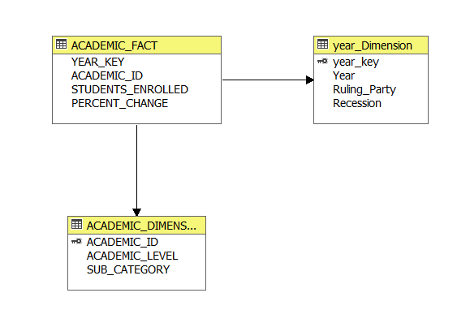

**Reports created using Excel connection to cube:**

What are the most popular degrees pursued by international students over the years?

How many international students enroll in institutes in United States across years?

## ETL process

**Initial Load Process:**

**Data Extraction:**

Extraction of the data from different data sources, most of which was available in excel files.

**Data Preparation:**

* Merged the data using excel.
* Data Cleaning using Excel.
  + Filtered the required data before loading it to data warehouse.
  + Removed the NULL values.
  + Consistency check of the data.
* Segregated the data into dimensions first using excel functions.
* Prepared the fact table data using VLOOKUP function to look up the keys from dimensions.

**Data Load:**

Used ‘Import Data’ in SQL Server to load the data from source excel files to destination tables.

**Recommendations for a sustainable ETL process:**

* Use of tools such as SSIS to perform ETL in order to handle large amount of data effectively without much manual work and more flexibility.
* Data should be loaded to staging tables before loading the data to a data warehouse. All the source data should be merged in the staging area and transformations should be performed in the staging area. This will avoid loading corrupted data to the data warehouse which will be difficult to revert back.
* The data preparation (getting the data from source system or source files and converting it into the form required for data warehouse) should be done in separate layer so that any changes does not affect the other parts in the process.

We changed our initial load process and used SSIS packages to load data to data warehouse. Below steps were performed for an improved and more flexible ETL process:

* Use of File enumerator in SSIS to read multiple files and merge them together and load it to staging tables.
* Use of sql queries in Execute SQL task to filter the data and perform aggregations.
* Load dimension tables first by querying the unique attributes values for dimensions from staging table.
* Prepare the fact table data by using lookup transformation to get the keys from dimensions.
* Load the fact tables.

## Analysis

### Theme 1: F1-visa and student enrollment:

1. Analysis: How international student enrollment in the US has changed over the years? Does F1- visa acceptance affected over the years? Which continent are more international students originating from? What are the top 10 countries with highest international student’s origin? Has the number changed over the years when the ruling party changed?
2. Analysis: Which states has the most expensive institutions? What type of institutions has the highest student enrollment rate? How does the tuition fee of an institution affect the student enrollment? What is the international student’s contribution for institutions?
3. Report: How has the student enrollment changed over the years?
4. Report: What are the most popular degrees pursued by international students over the years?
5. Report: What are the top 10 popular destinations for international students?
6. Report: Have the popular destinations changed over the years?

#### F1 Visa Analysis

F1- visas are issued to international students to engage in long-term studies in US higher education. State departments now reports a total of 362,843 F1 visas issued for the year 2018. This represents a 12% decline from year 2015 to 2018. Due to the on and off ban on Muslim majority countries in 2017-18 and the US presidential elections in 2016 had a huge impact on the non-immigration visas like F-1. The decline also indicates that US visa policy has generally become more restrictive, with more scrutiny of incoming international students, over the last two years.

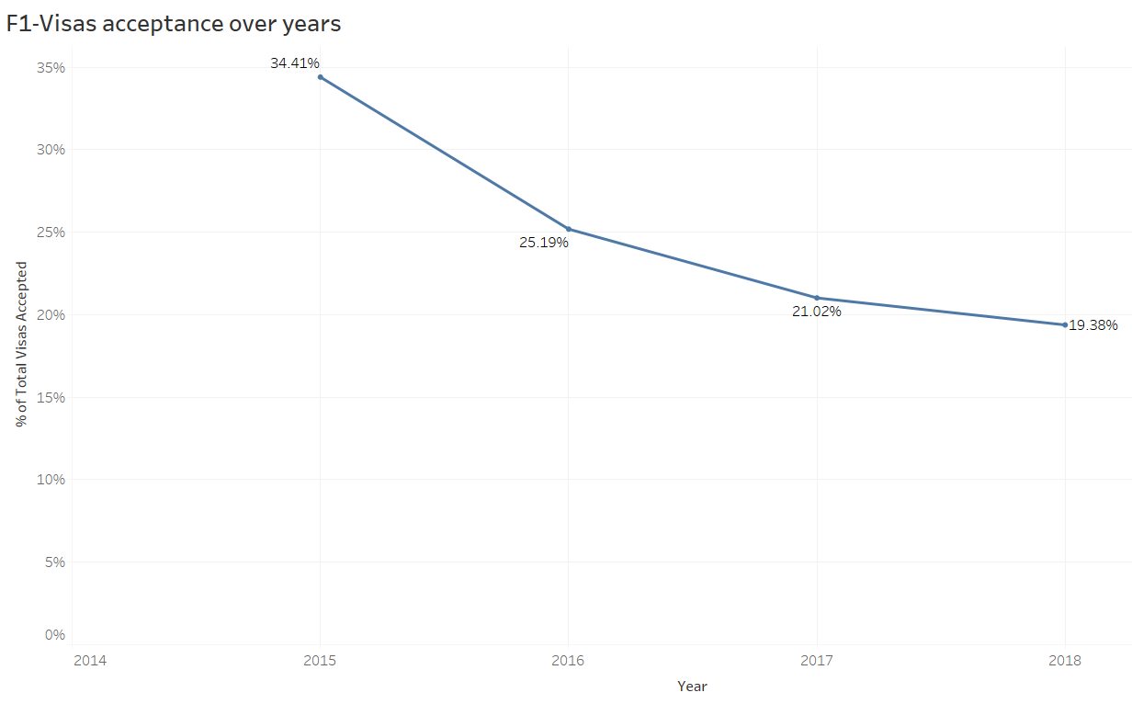

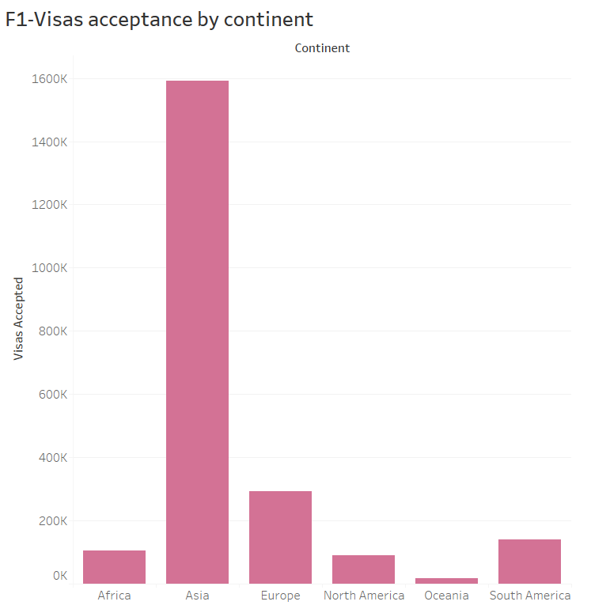

The F1-visa acceptance rate is high for Asian countries followed by European countries. US has become a tougher destination for international students to stricter scrutiny of those who do apply from African and Oceania countries.

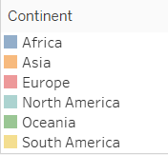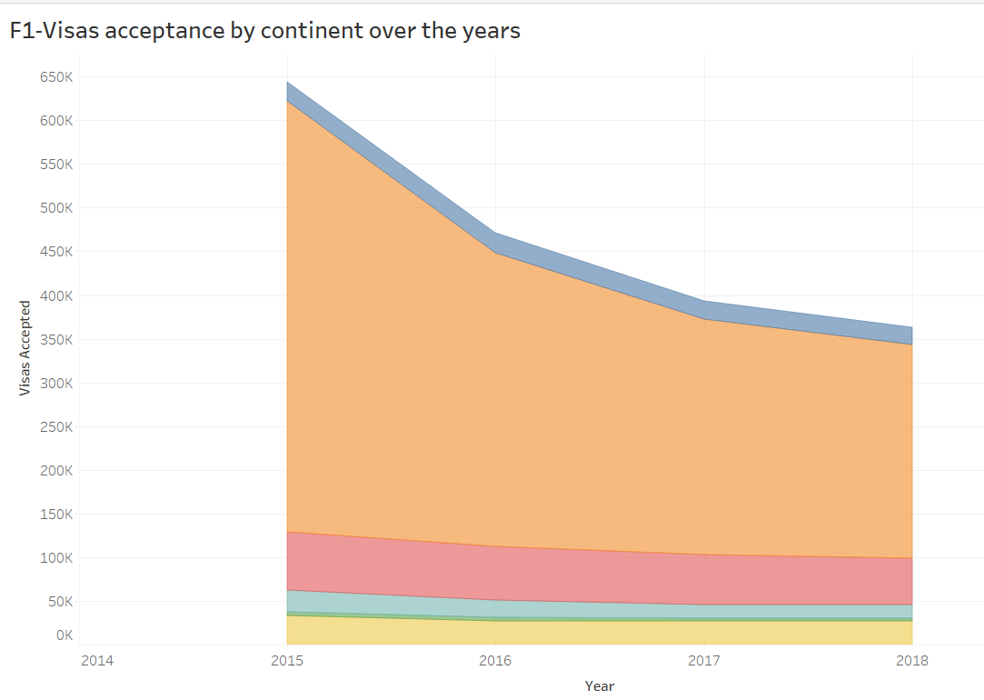

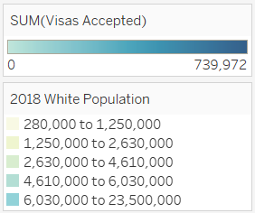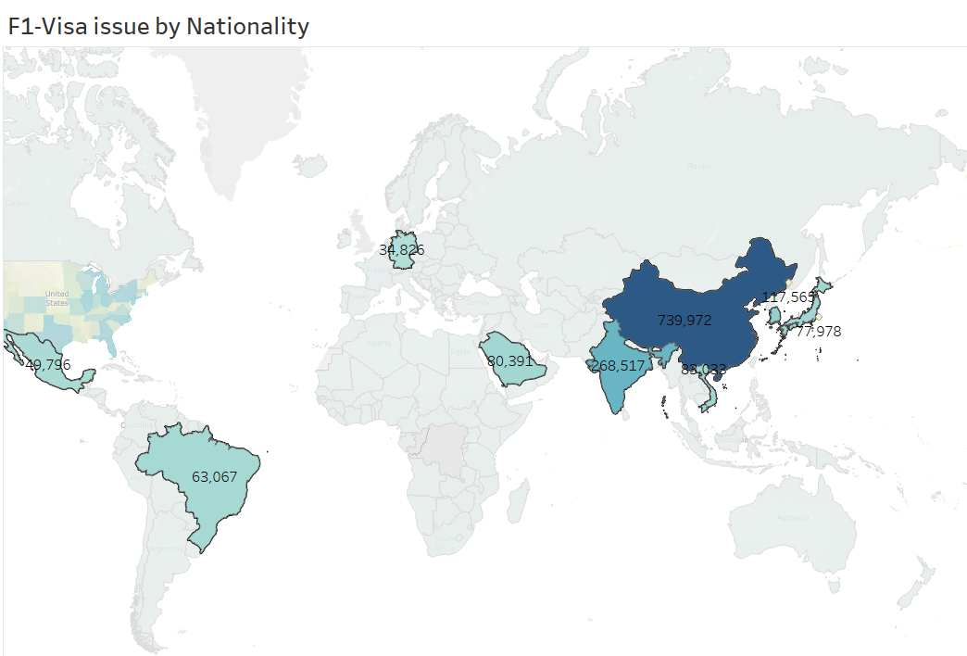

The top five countries for whom visa acceptance rate is high are China, India, South Korea, Vietnam and Saudi Arabia followed by Japan, Brazil, Mexico, Germany. *The department never reveals the number of applications received, hence we cannot compare the rejection rate for different countries.*

Students from China, India and South Korea accounted for more than half (54%) of all newly enrolled foreign students pursuing degrees at U.S. colleges and universities.

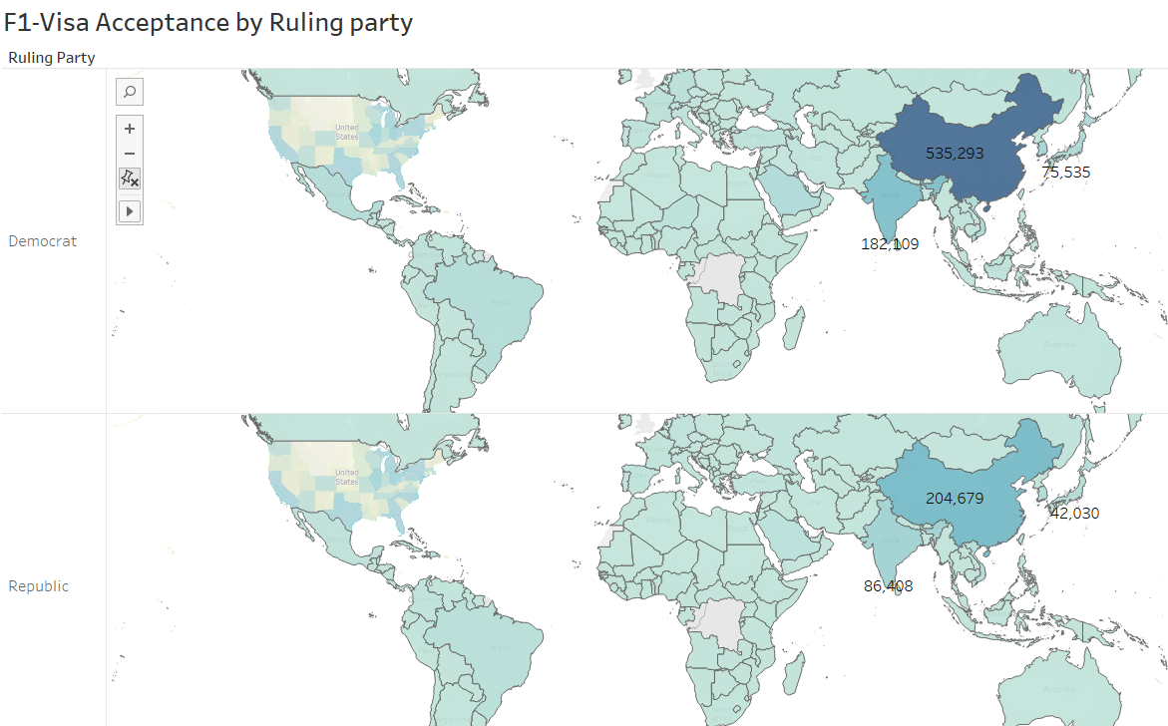

There is a 52% drop in the number of visas granted to Indian students and a 60% decline in visas for Chinese students when compared for ruling parties. These are of course the number two and number one sending markets for the US, respectively, and they have collectively contributed the lion’s share of overall enrolment growth for US schools in recent years.

#### b. Student Enrollment Analysis:

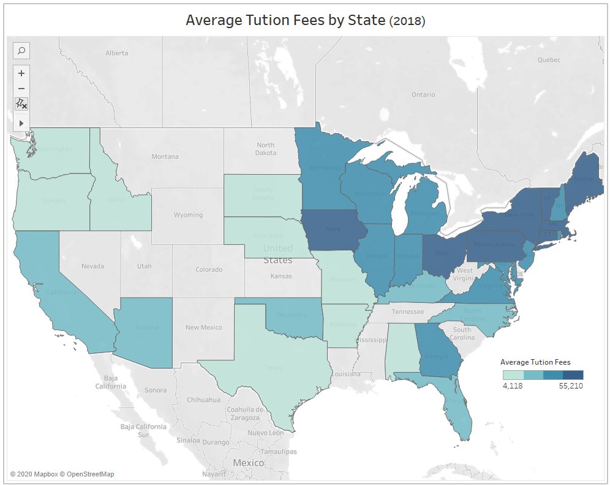

Exploring the average fees by state, we noticed that states like Iowa, Ohio, New York, Pennsylvania and other states in dark blue are expensive to go to. College education in California is affordable which can be a contributing factor to its being a popular destination for international students.

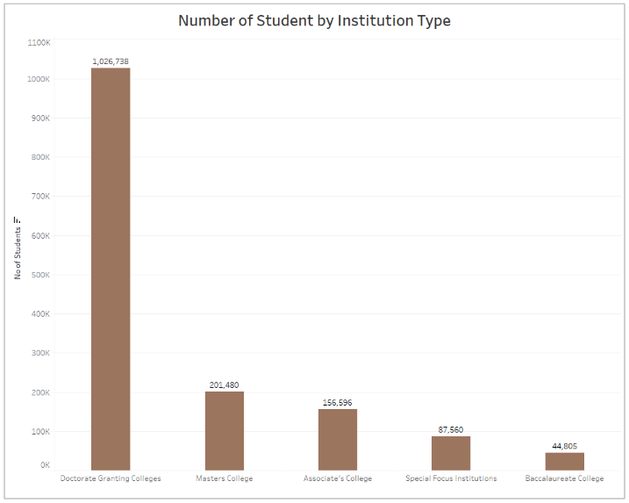

The graph above shows what type of institutes attract the highest number of international students. 68% of students enroll themselves in doctorate granting colleges followed by master’s colleges which makes up 13% of the international students. The least number of students, which is 3 % approximately, go to Baccalaureate colleges.

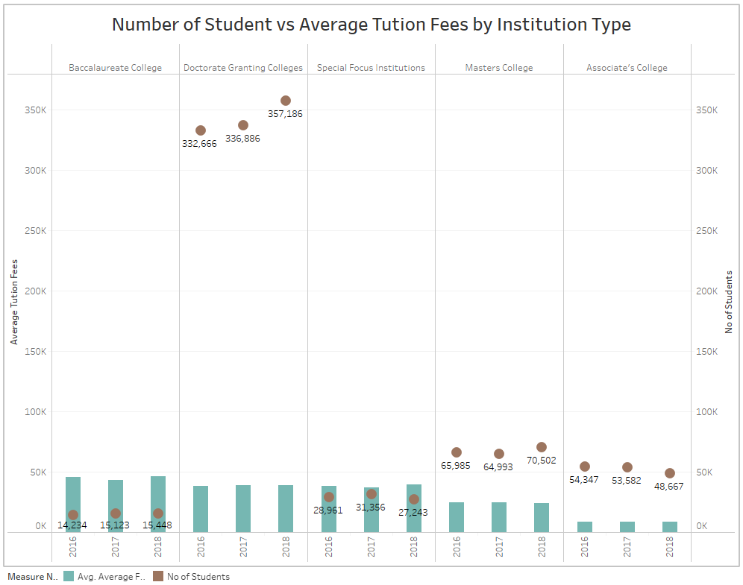

To gain more insight, a comparison between the number of students that enrolled themselves in a particular institution versus the average tuition fees college charges was done. It was found that Baccalaureate colleges charged the most fees followed by Doctorate granting colleges. The most affordable type of colleges is the associate’s colleges which have the lowest average tuition fees followed by master’s colleges.

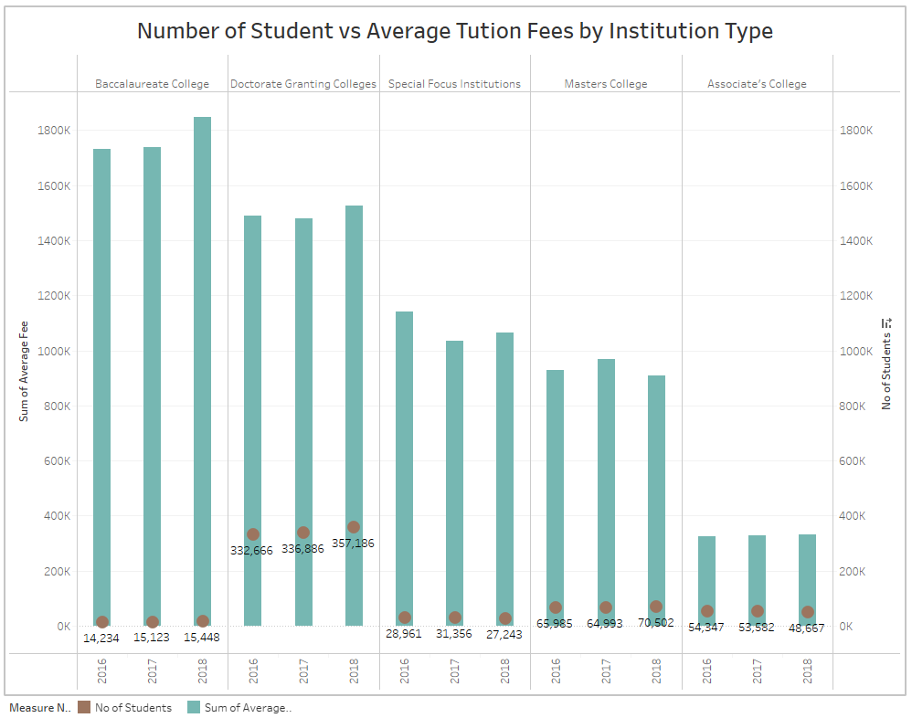

From the analysis of yearly trends of the tuition fees, we noticed that there are slight increases every year for every type of institution we also noticed that number of students are also increasing every year for the doctorate granting colleges and for the Masters colleges but we see slight decrease for the associate colleges, special focus institutions and baccalaureate colleges.

#### Reports:

c. How has the student enrollment changed over the years?

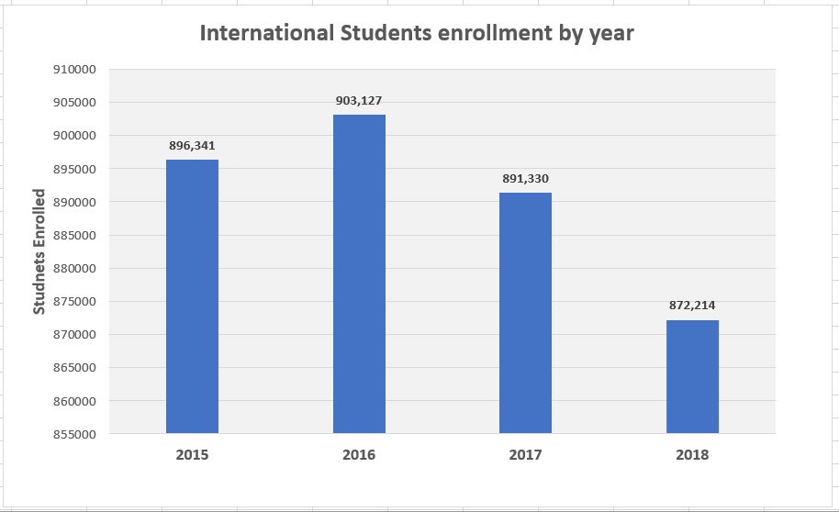

The above report shows the student enrollment across years. The number of international students enrolling has significantly reduced from 2016.

d.What are the most popular degrees pursued by international students over the years?

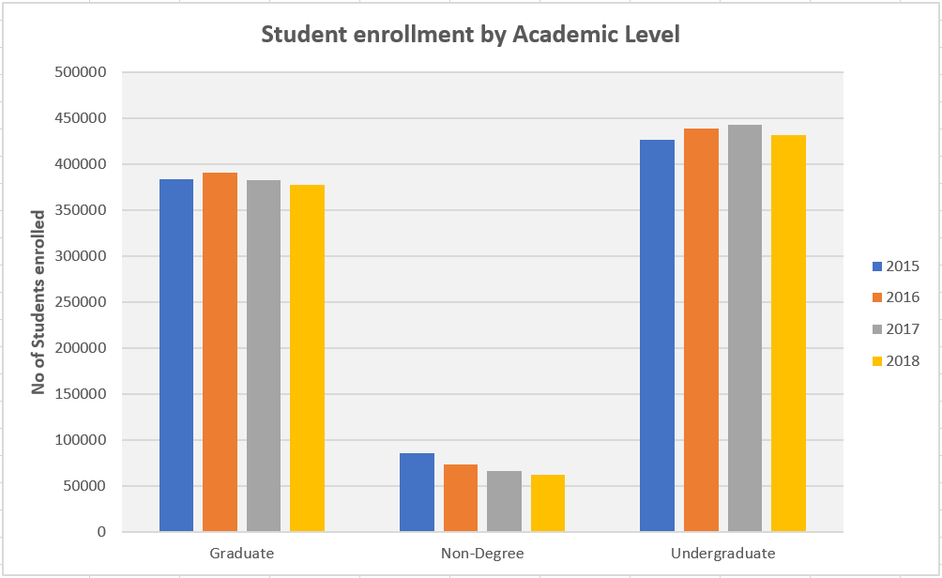

The above report shows the most popular degrees pursued by international students over the years. There is a decrease in number of students enrolled in undergraduate, graduate and non-degree courses.

e.What are the top 10 popular destinations for international students?

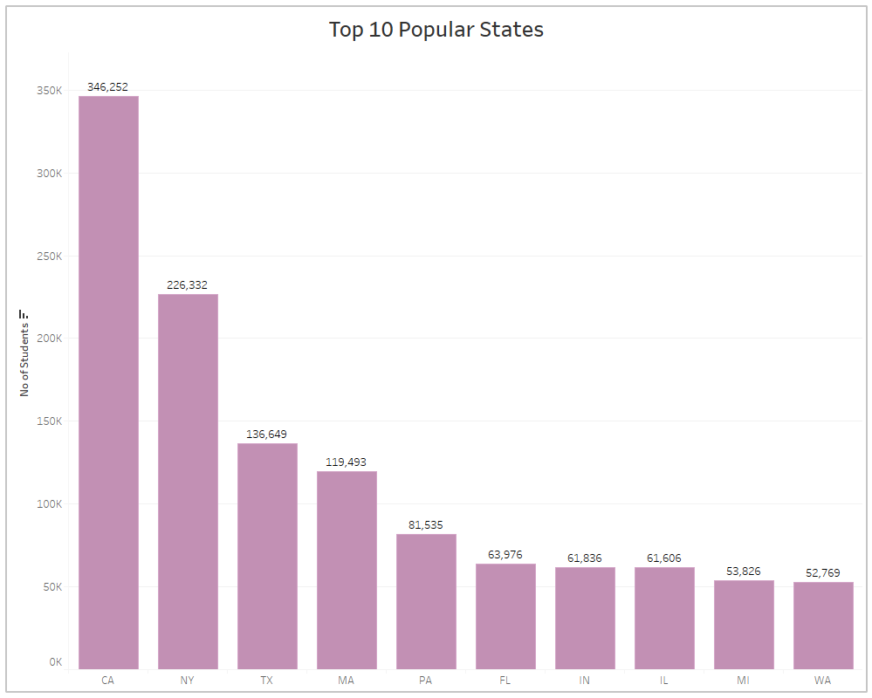

The above visualization shows the most popular states that international students choose as their destinations. California is the most popular state for international students in United States.

f. Have the popular destinations changed over the years?

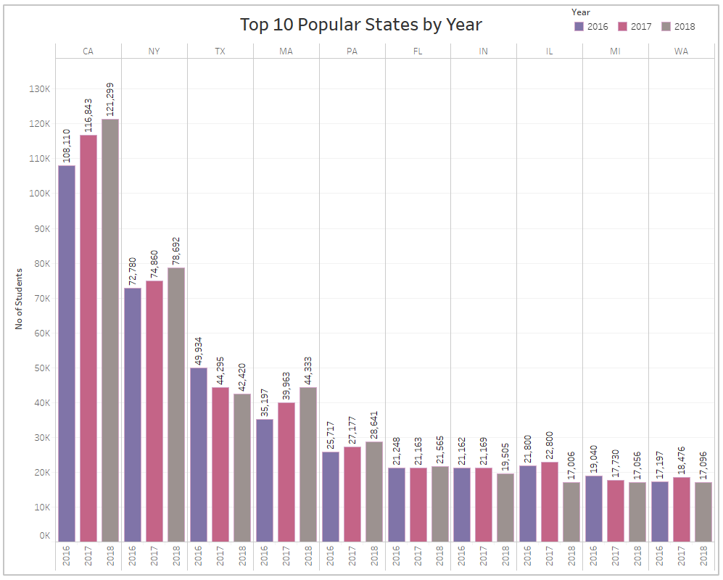

The above visualization shows the top 10 popular states over the years for international students.

### Theme 2: H-1B Visa and International Students Job Statistics

1. Analysis: Which states has the highest number of positions for H-1B sponsorship? Which companies file for highest number of H-1B petitions for new employment? Do the companies differ for continuing employment for H-1B filing? How has the denial rate changed over time? What can be the reason for the change in H-1B denial and acceptance rates? How does it affect companies?
2. Analysis: Which industries have more opportunities for international students in getting jobs that offer H1B visa sponsorship. Do these occupations or job roles in IT have better average salary when compared to other industry job roles?
3. Report: How does the number of H-1B petitions filed has changed over the last 5 years?
4. Report: What are top 10 job roles for which employers are filing H-1B in last 3 years?

#### H-1B Visa analysis:

Foreign nationals require H-1B sponsorship to work in United States. The analysis starts with discovering the states which has the highest number of petitions filed from 2015-2019. The top 10 states are California, Texas, New Jersey, Illinois, Colorado, New York, Michigan, Massachusetts, Arizona and Georgia with California being the highest with around 450 K petitions filed so far. This gives an idea of which states has higher number of positions for which employers are filing for H-1B.

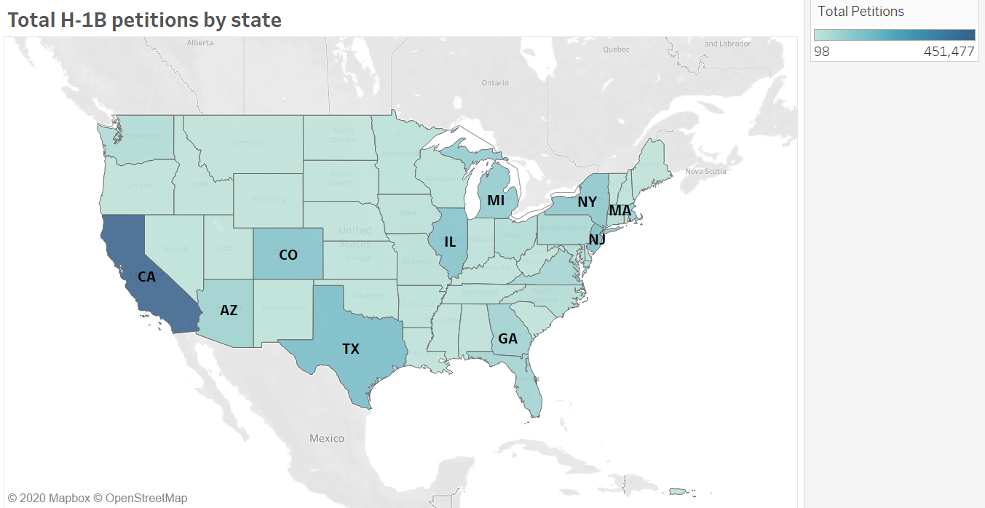

Not every employer in US files for H-1B sponsorship. The next part of analysis shows the top 10 employers who have filed for highest number of H-1B petitions for new employment and continuing employment over the span of five years 2015-2019.

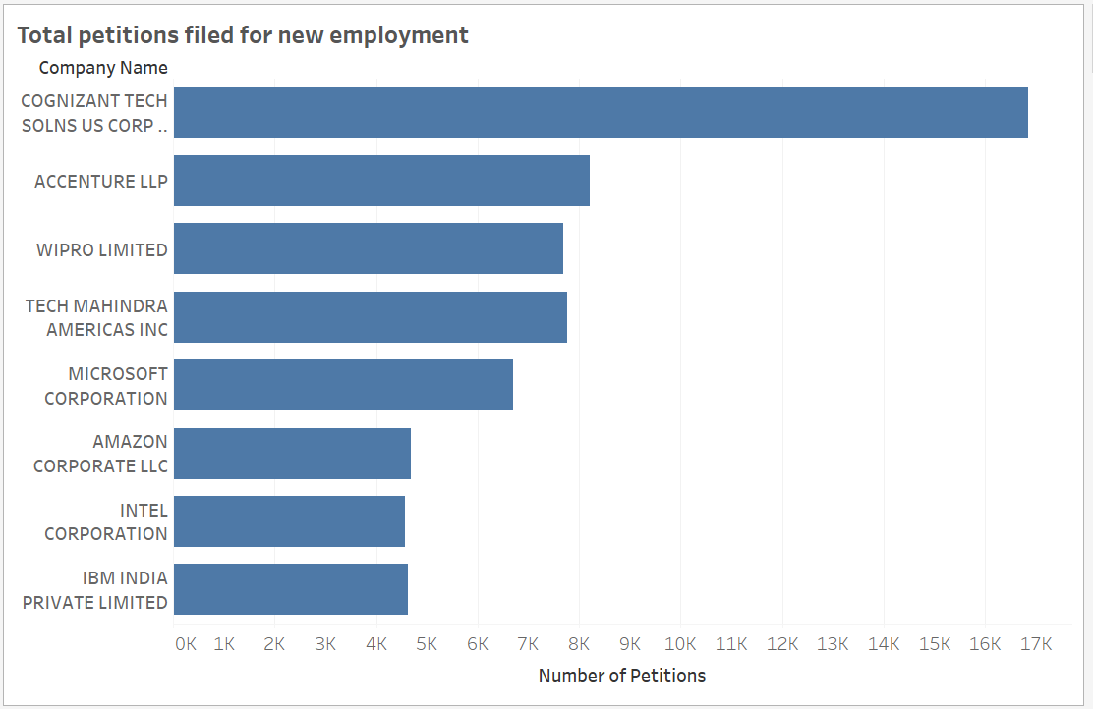

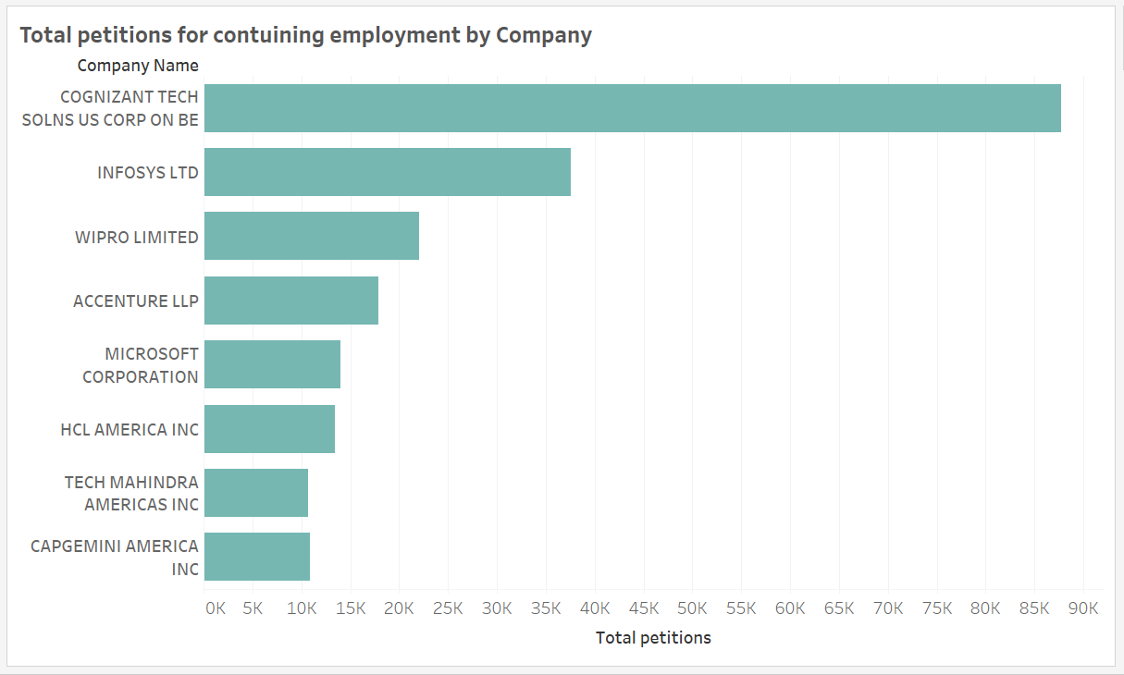

The top companies are Cognizant, Infosys Ltd, Wipro Limited, Accenture LLP, Microsoft Corporation, HCL America Inc, Tech Mahindra America Inc, Capgemini America Inc with Cognizant being the one with highest number of H-1B applications.

These companies have filed the highest number of visas in Information and Professional and Technical Services sector. These include software, computer systems, networking, telecommunication, data etc. related opportunities.

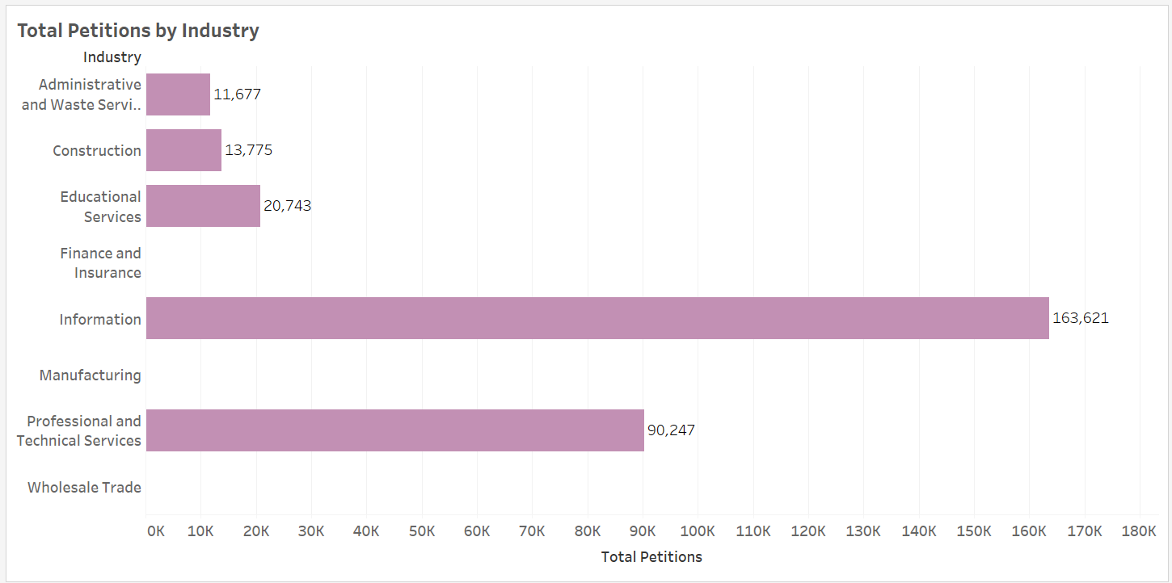

After the changes in the policies regarding H-1B in 2017, the process for H-1B sponsorship has become more tedious and applications has been strictly scrutinized by USCIS. There have been more RFE’ s issued by USCIS for verification of employment. The denial rate has increased drastically from 2017. It has jumped to 16% in 2018 from 7% in 2017.

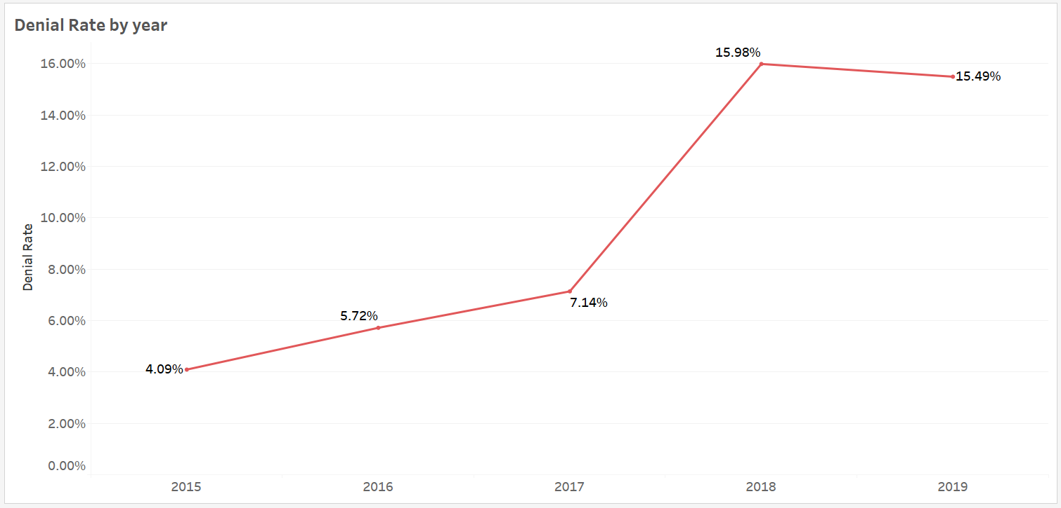

More importantly, it has affected the outsourcing and offshoring companies such as Infosys Ltd, Wipro Limited etc. Although, these have remained some of the biggest new H-1B visa recipients, they have been seeing a marked decline in numbers they are granted.

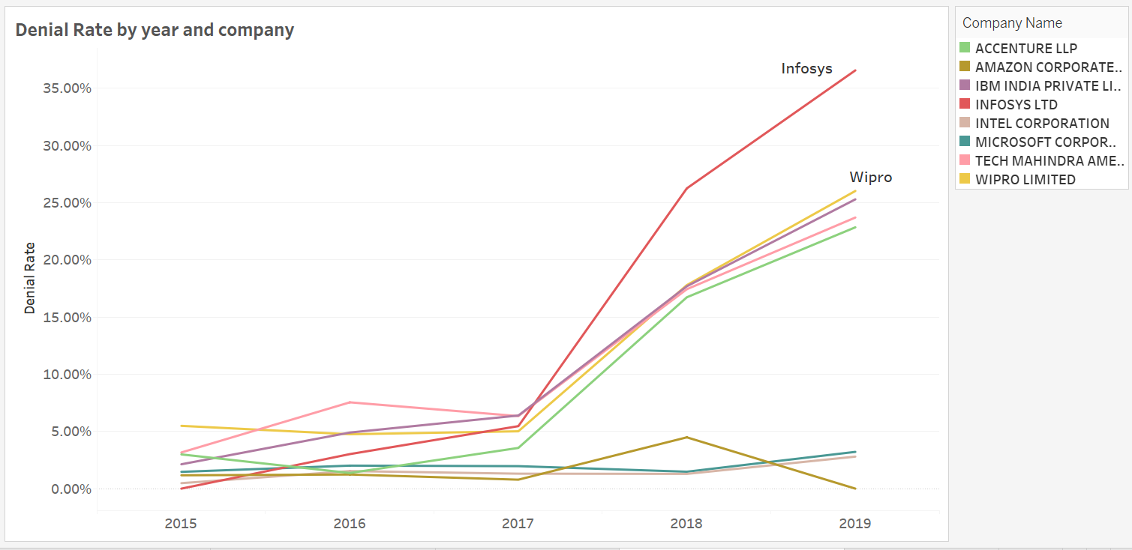

#### H-1B job statistics for international students

One of the major concerns of any intending or graduating student is the job opportunities that exist in his/her chosen field of study. This is a big concern for international students as there are certain criteria’s and policies that they have to meet to be eligible for employment and awarded an H1B visa that enables them to work.

The objective of this analysis is to give an overview of occupation and job roles where international students had more Job offers and subsequently had the company file for their H1B visa, top paying jobs that had offered H1B visa and bottom jobs that had the lowest applications for international students in the United States of America. This guide serves as an informative material and guide to international students and could be used for research.

**Top 5 Occupations with highest H-1B visa applications/visa acceptance**

IT related jobs seems to have the highest number of offers for international students. They also have the highest number of H1B acceptance across time. The graph below shows the top 5 jobs that had the highest indices. Software developers (Applications) had the highest visa acceptance and it has evolved to be the leading job role in 2018 with over 165,094 applications being accepted. These top occupation categories will be a good suggestion for internationals who want to come for studies and also for graduating students to try and get IT skills in various specializations.

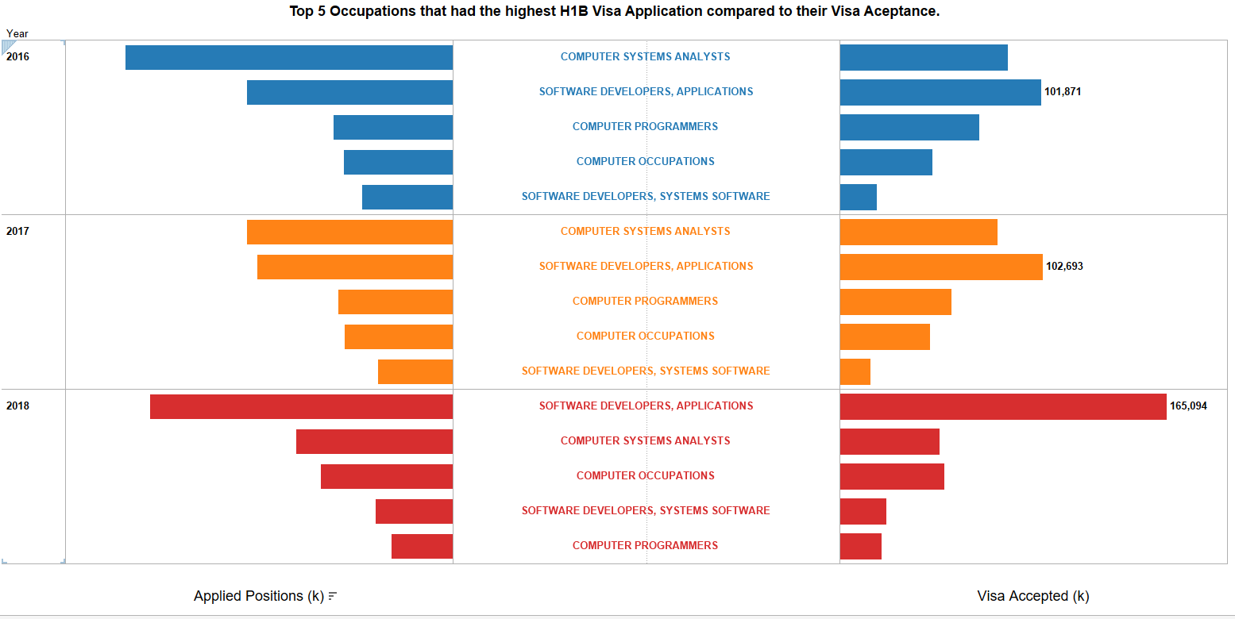

**Average Salary for top 5 occupation with highest H-1B visa acceptance**

The average salary for the top most occupations that offered international students’ jobs is shown in the below graph across three (3) years. In 2016 and 2017 Computer system analysts had the most job opportunities for international students with an increasing average salary by the year. However, in 2018 Software developers (Applications) had a spike with an average salary going up from 92k in 2016 to 102k in 2018. The minimum average salary in all five categories was 75k, making these jobs very attractive.

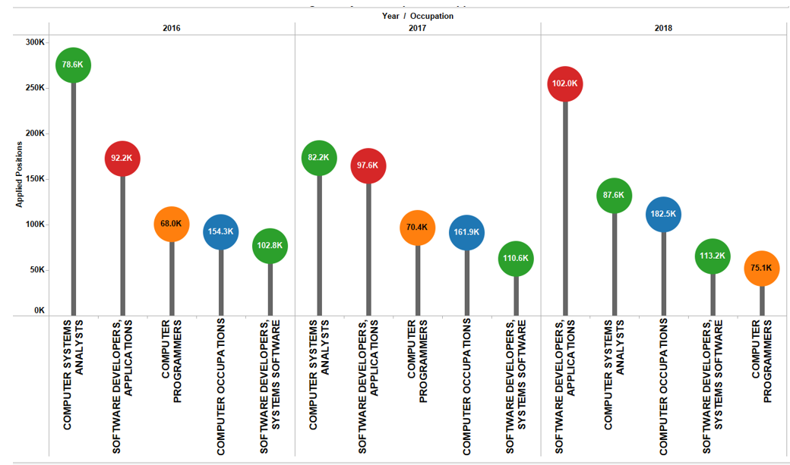

**Top 10 average salaries by occupation**

Jobs with the highest average salary were however different from jobs with the highest Visa applications. While IT jobs became the highest employer of international students, Medical Job roles had the highest average salary across the years. These are professional areas that guarantee good pay. This however is a league for a few internationals as the cost involved in the medical fields make it difficult for many internationals to get involved with it.

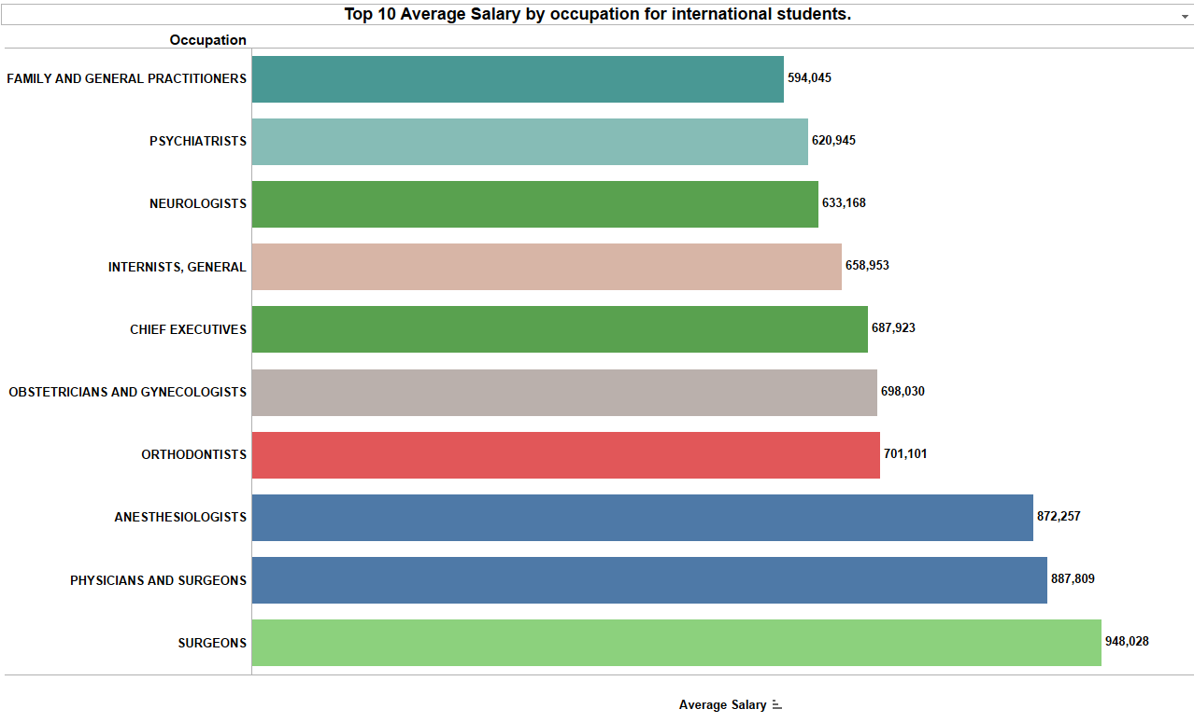

**Average Salary of occupation with least H-1B applications**

The Job roles where international students had the lowest offers includes Accounting and Auditing Jobs, Agricultural science, Architects, Advertising and Teaching Jobs. Interestingly, Animal scientist occupation had an average salary as high as 130k.

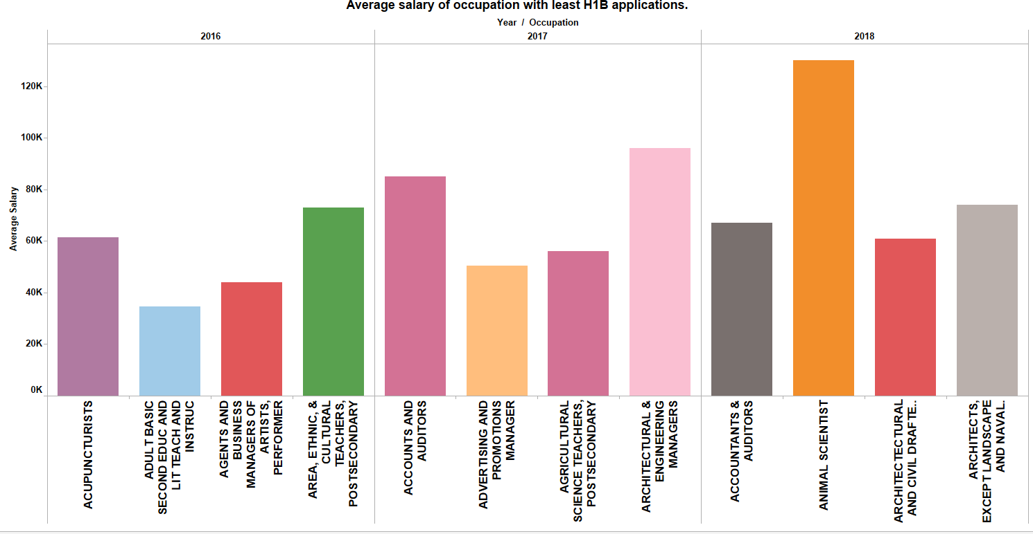

This analysis has provided a brief overview of what employment and HIB visa trends are along occupational considerations. This will help in effective planning, focus and preparation by international students.

#### Reports:

1. How does the number of H-1B petitions filed has changed over the last 5 years?

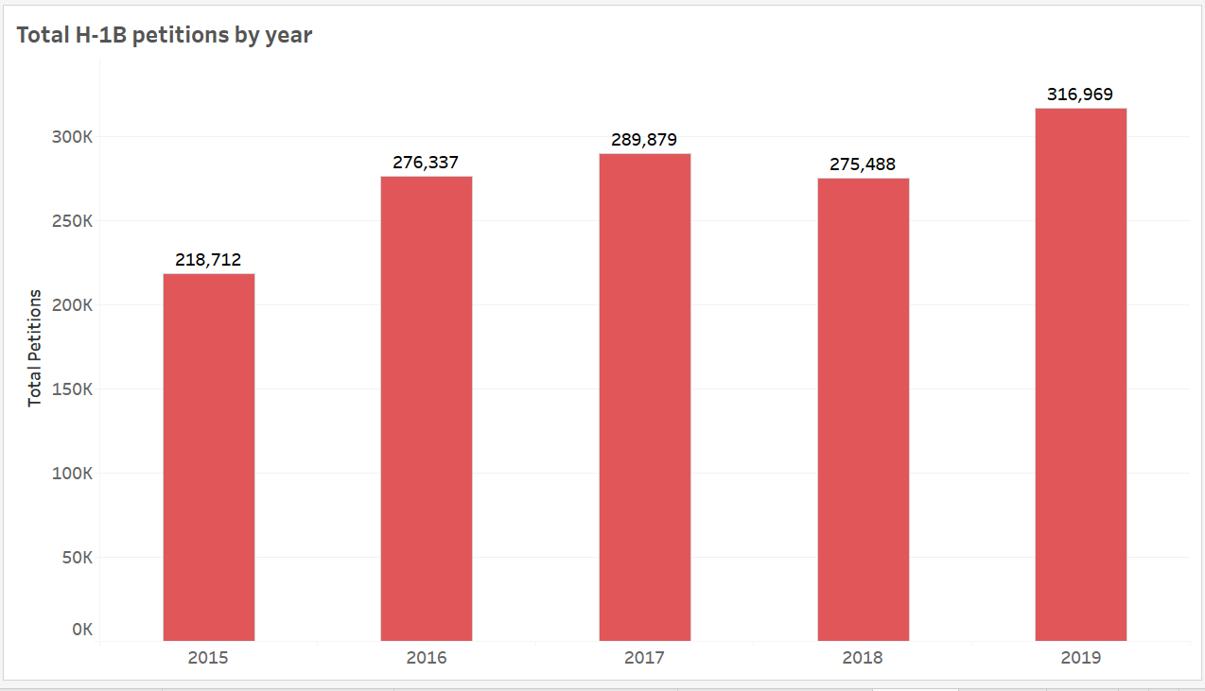

The above report shows the trend in number of H-1B visa applications filed across years. There was a decrease in the number of applications in 2018 but the year 2019 has recorded the highest number of H-1B petitions.

1. What are top 10 job roles for which employers are filing H-1B in last 3 years?

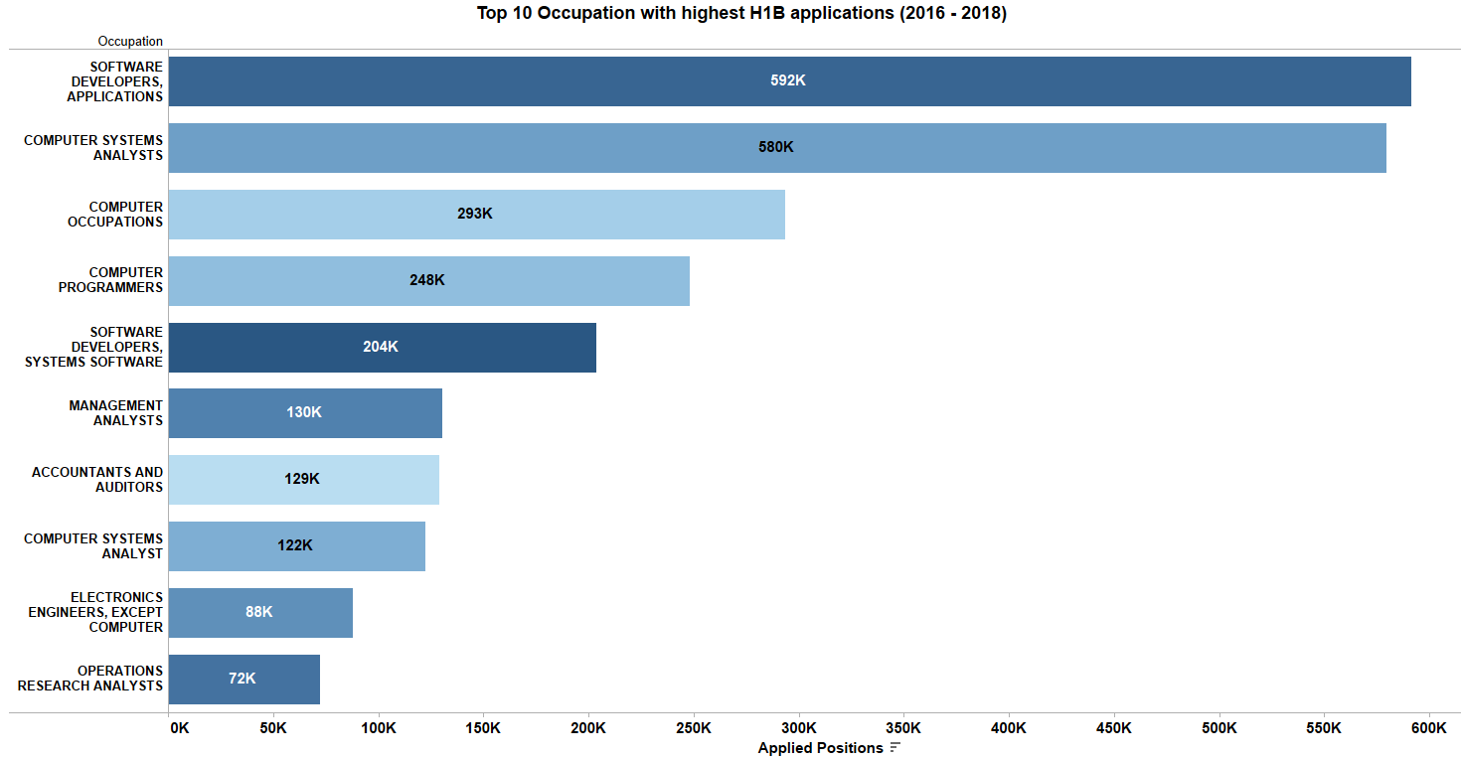

The above report shows the top 10 job roles for which the highest number of visa applications were filed. Software developers has the highest number of visa applications filed in last 3 years.